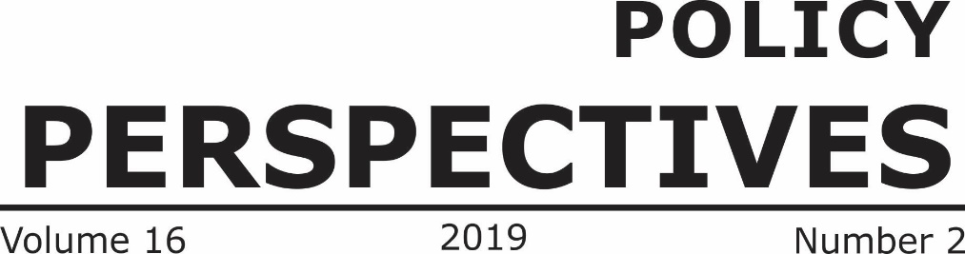

**Volume 20 2023 Issue 2**

**CONTENTS**

|  |  |
| --- | --- |
| **In this Issue** | **iii** |
| *Research Articles* | |
| **Military Court Trials of Civilians in Pakistan: Between Constitutional Rights, International Obligations and Sustainable Justice**  - *M Hassan* | **01** |
| **Interplay of Ontological (In)Security Management Routines: Phase Transitions in Pakistan's Tribal Area amid Relations with Afghanistan**  - *Dr Farhat Taj* | **19** |
| **Politics in Times of Pandemic: Political Institutions and State Governance Issue of Pandemic Treaty-- by Lala Jafarova**  - *Lala Jafarova* | **41** |
| **Social Media and Mob Violence: The Need for an Effective Social Media Policy**  - *Dr Tughral Yamin* | **57** |
| **Institutionalization of Zakat and Waqf in Contemporary Economies: Challenges and Prospects**  - *Dr Salman Ahmed Shaikh* | **73** |